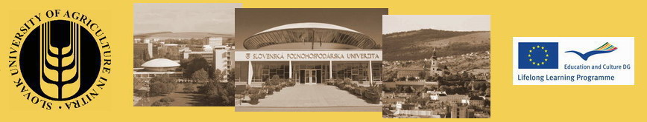
Travel Cost Refund
LLP ERASMUS INTENSIVE PROGRAMME
Ecological production systems for environmental and human health (EPSEN)

FILL IN, PRINT, SIGN and return with the ORIGINALS OF TICKETS/ INVOICES to:
Ing. Beata Srňanská
Slovak University of Agriculture
Tr. A. Hlinka 2
949 76 Nitra
Slovakia

Your name:
I travelled by: bus train plane car
Refund of my costs should be send to the following account:
Account holder:
Address of the account holder:
Name of the bank:
Address of the bank:
Account number:
IBAN:
Swift code of the bank:

Date:……………………………… Signature:………………………………

No refund will be possible without originals of tickets, invoices and account statement indicating the payment!
Travel cost refunds rules
100% of your real travel cost will be refunded after the Intensive program only upon sending the originals of bus ticket /train ticket / plane ticket+ boarding passes. If there is not the full price given on the ticket the original invoice with stamp will be required too.

In case of travelling by car the costs can be refunded in the price of bus or train ticket (single or return) upon sending a written confirmation of the price of the ticket (single or return) issued by the bus company/ railways / travel agency with stamp and signature.

Participants have to use the most economic means of transport.

